Given an array rectangles where rectangles[i] = [xi, yi, ai, bi] represents an axis-aligned rectangle. The bottom-left point of the rectangle is (xi, yi) and the top-right point of it is (ai, bi).

Return true *if all the rectangles together form an exact cover of a rectangular region*.

**Example 1:**

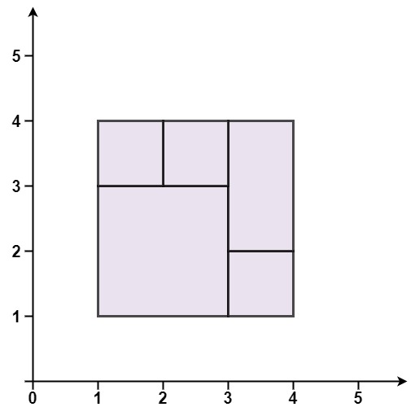

**Input:** rectangles = [[1,1,3,3],[3,1,4,2],[3,2,4,4],[1,3,2,4],[2,3,3,4]]

**Output:** true

**Explanation:** All 5 rectangles together form an exact cover of a rectangular region.

**Example 2:**

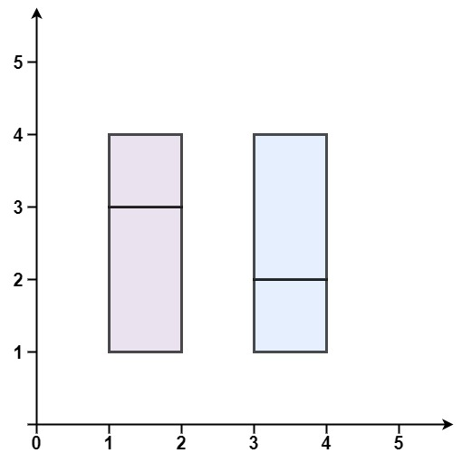

**Input:** rectangles = [[1,1,2,3],[1,3,2,4],[3,1,4,2],[3,2,4,4]]

**Output:** false

**Explanation:** Because there is a gap between the two rectangular regions.

**Example 3:**

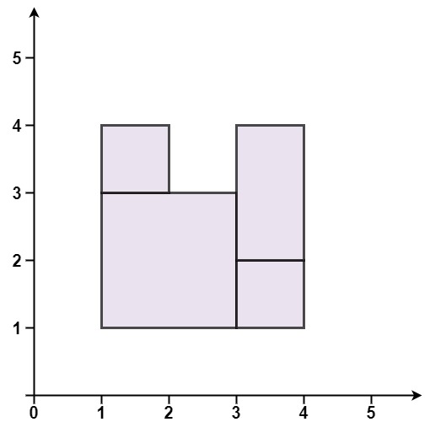

**Input:** rectangles = [[1,1,3,3],[3,1,4,2],[1,3,2,4],[3,2,4,4]]

**Output:** false

**Explanation:** Because there is a gap in the top center.

**Example 4:**

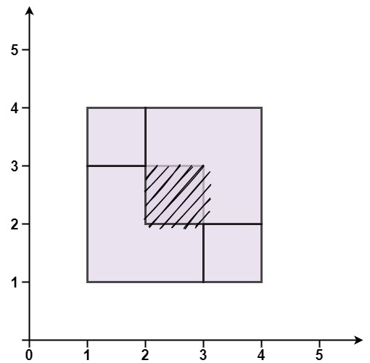

**Input:** rectangles = [[1,1,3,3],[3,1,4,2],[1,3,2,4],[2,2,4,4]]

**Output:** false

**Explanation:** Because two of the rectangles overlap with each other.

**Constraints:**

* 1 <= rectangles.length <= 2 * 104
* rectangles[i].length == 4
* -105 <= xi, yi, ai, bi <= 105